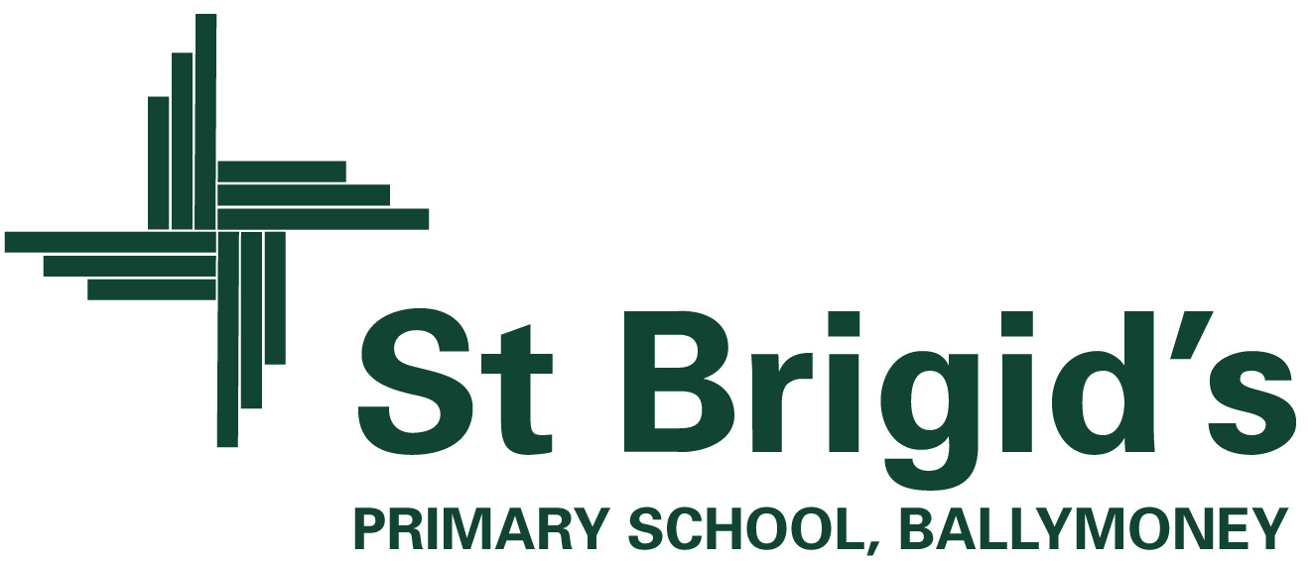

Curriculum Newsletter P2 Term 1 2026

What else is happening in the curriculum?

Homework: Homework will be sent home on a Monday and the red homework folders will not need to be brought into school until they are due for return each Friday morning. Our P2 homework will be presented in a short A4 booklet with spellings, reading log and homework activities all within the one booklet to make it more manageable going between home and school. This booklet will be marked when brought in on a Friday and will then be sent home for you to keep. Please ensure your child has written their name at the top of their booklet each week. Keep Friday test sheet attached to the booklet as this is used in school on a Friday. We will continue to use the Seesaw App to assign a few homework activities to your child throughout the school year. Two reading books will be given each week. The spelling of sounds or rhyming words and tricky words will be tested each Friday based on the given set assigned to each individual child.

ICT: Children will program the Beebot robot to move around the supermarket mat using a series of instructions during. They will use the ipads and computers to engage in Literacy and Numeracy activities on a daily basis.

Numeracy: We will be working on identifying numbers 1-30 and beyond, as well as beginning to look at adding and subtracting. This will lead us onto exploring number stories and bonds to 10. We will be naming odd/even numbers and using money to 50p: 1p, 2p, 5p, 10p, 20p, 50p. Pattern, sorting, shape and data handling work will be revisited throughout the term.

P.E: Children will enjoy P.E. on Tuesday and Thursday. On these days, please send your child to school wearing their P.E. shoes.

Hello, I would just like to introduce myself I am Miss Johnston, and I am so excited to get to work with your lovely boys and girls this year. I value supporting both academic and social/emotional wellbeing and hope to reflect this consistently in our classroom. If you have any questions, feel free to send me a message through Seesaw and I will try to reply within the hours of 2pm-4pm.

The World Around Us
(Science, Technology, Geography and History)

The theme we are studying at the beginning of this term is ‘Wonderful Me’.

The focus of this topic is to help the children gain a greater understanding of ‘Ourselves’, our bodies and how to care for them. We have an exciting few weeks ahead of us in P.2! We will be busy learning about our senses, carrying out experiments based on investigating the role they play in our daily lives. This topic has already led us to looking at our unique characteristics e.g. hair colour and eye colour. We will write facts about our body and will discuss our uniqueness by looking at our fingerprints and focusing on our talents. We will be considering adjectives to describe ourselves and will discuss what makes us special. We will have an Optician’s set up in our role play area and we will be re-enacting the roles of clients, secretaries, and optometrists. We will visit our local Opticians and will go on a sense walk up Main Street in Ballymoney. Any parent who works in the healthcare profession who would like to talk to the class about what they do would be very welcome to share their knowledge with our class.

Our Topic will change to “Yum, Yum” in the second half of the term. The children will investigate the importance of having a healthy and balanced diet. We will look at different types of food, sorting them into what we think we should eat most or least often and we will be investigating the hidden sugar content in foods and drinks. This topic will allow huge potential for investigation and research. For example, we will be looking at the importance of storing food in the correct place and we will be studying food labels to discover where in the world our food comes from and mapping the journey it makes before arriving on our plates!

We will be really busy bees!

Included in themed work are creative activities, simple science investigations, activities which explore our environment and activities which use information technology.

What’s going on this term?

P.2 will be getting busy inside and outside the classroom! We will get outdoors to explore the changes ‘Autumn’ brings as well as going on various adventures in order to use each of our 5 senses in our surroundings. We will be grasping opportunities to use the outdoor classroom for play based learning.

Class Contract

In order to secure a happy and safe learning environment, P.2 have agreed upon the rules (overleaf) which we have devised together. You will notice that these are presented in a positive ‘We can’ way. We will strive to achieve them and succeed in keeping them.

‘Superstar Points’ will be awarded to each table whenever they work well together as a team. The table of the week will be rewarded each Friday, and they will choose their reward so this will vary. As a whole class pupils will have the opportunity to earn “ducks in the jar”, they can earn a duck by demonstrating positive whole class behaviour during assembly class time and for good, quiet lining up, once all 100 ducks are in the jar they will be rewarded with a class party. Pupils have already earned a duck and are very excited by it. Pupils will have their own ducks and if they demonstrate positive behaviour related to our rules or good work, they will be able to move their ducks closer to the rainbow. When they reach the rainbow they will be rewarded with a prize from the prize box.


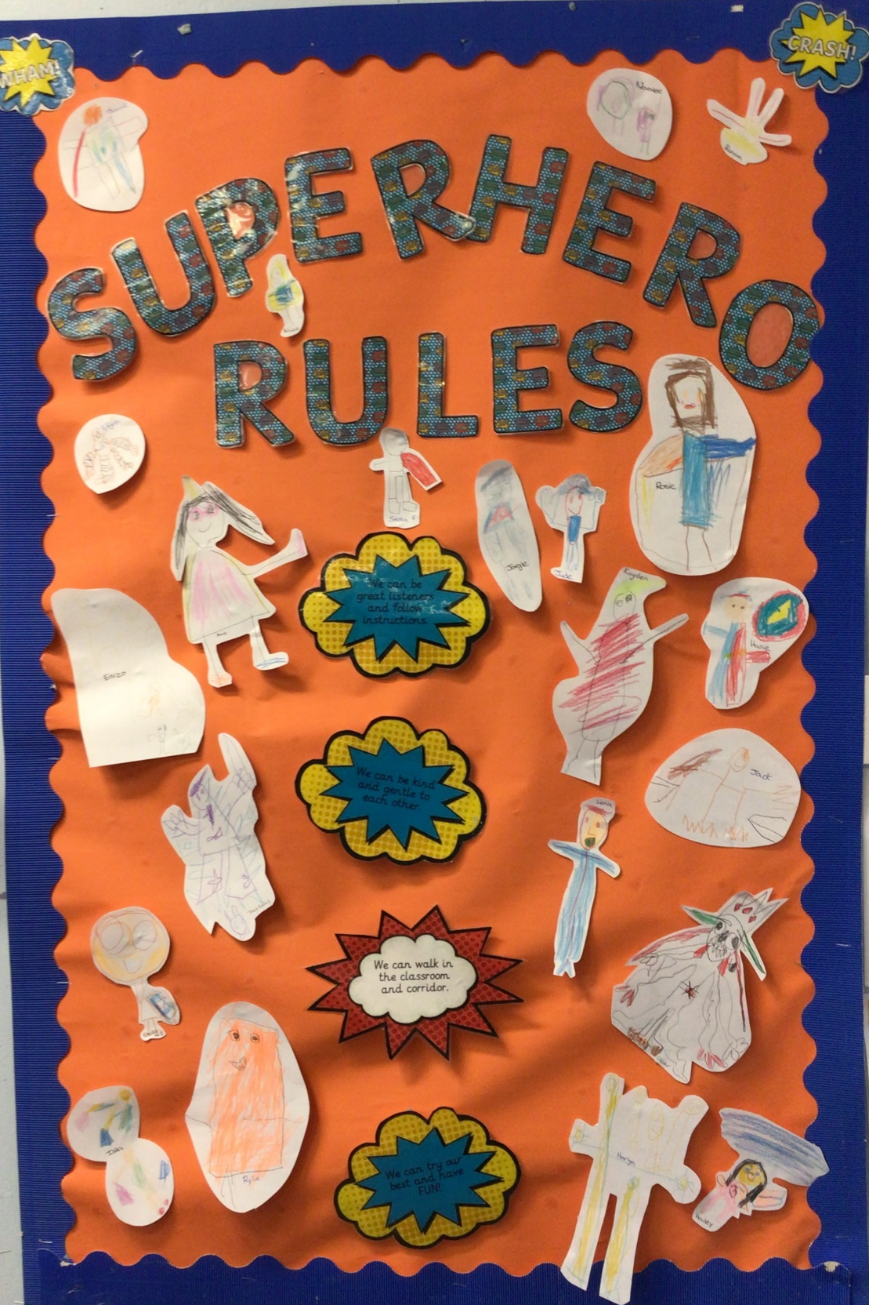
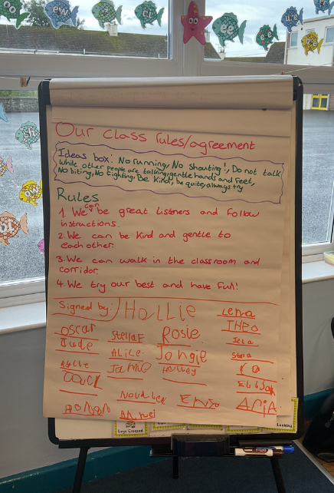
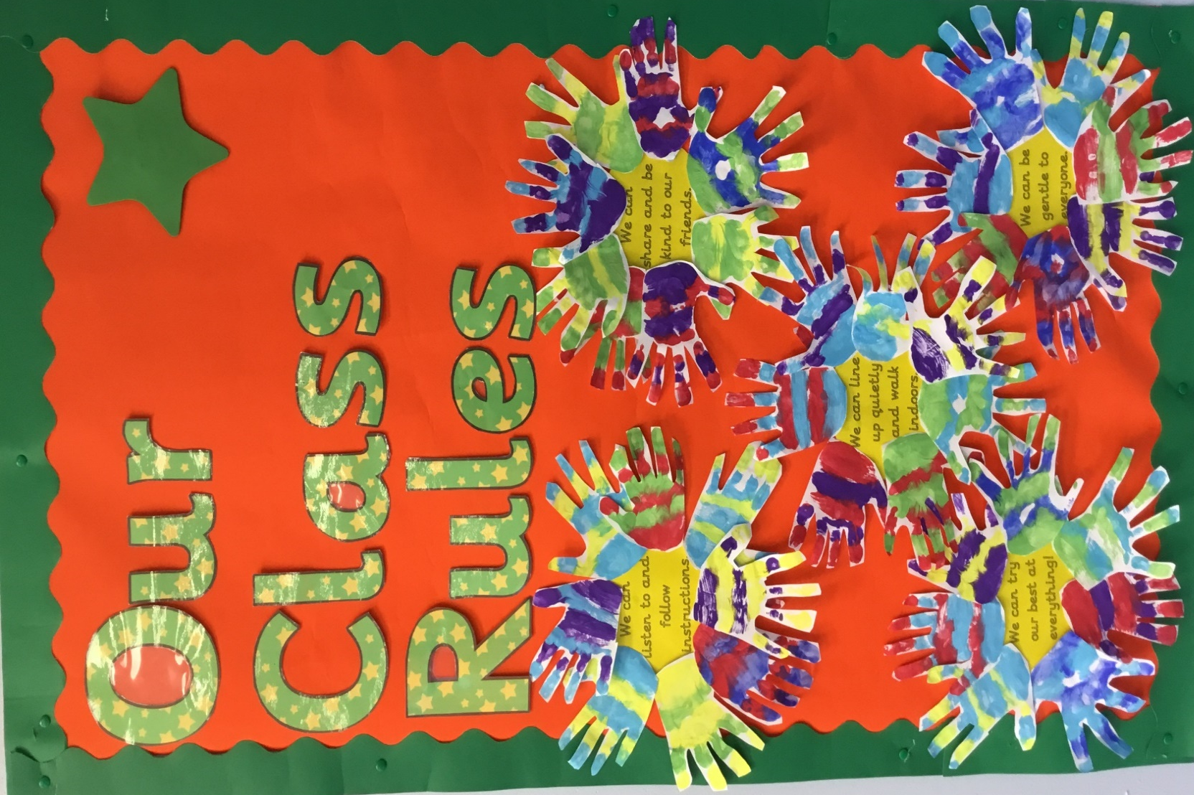

OUR PLAYGROUND RULES

- We can be a great friend.

- We can be gentle.

- We can follow instructions.

- We can play nicely.

- We can line up quietly.

In the playground, we will make a special effort to include everyone in our games and will always aim to be kind and gentle to those around us.

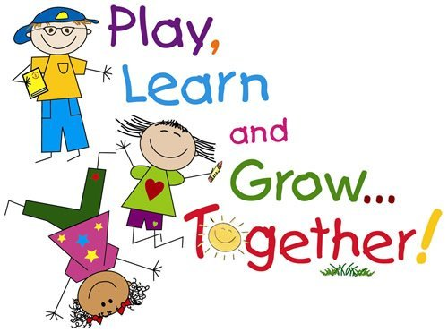

Our class motto in P2 is: “We can!”

- We can be great listeners and follow instructions.

- We can be kind and gentle to each other.

- We can walk in the classroom and corridors.

- We can try our best and have FUN!

