**SeeSaw –** This will be a very beneficial tool for us to maintain communication throughout the year, so please try to check for updates on a regular basis.

**Cooking –** Cooking will take place every 3rd Thursday and we try to plan a balance of sweet and savoury recipes. This is a fun, social part of the week as well as incorporating some key life skills for the children. To help cover the cost of food items, I ask for the sum of £5 for Term 1. Thank you.

**Class Agreement –** The children worked together to create our class rules. This is included on the reverse of this page.

**Library Visits** – Class B will be visiting the library every 3 weeks to read and borrow books.

The World Around Us

(Science, Technology, Geography and History)

Our theme for the term is **‘Our Town - Ballymoney’**

**Our study will include:**

* Mapwork to investigate Ballymoney’s location in the World, the U.K. and N. Ireland
* An exploration of significant features of Ballymoney town
* A study of famous people from Ballymoney
* Using a town map to plan a route for a trail around Ballymoney
* Road safety rules in preparation for our ‘Ballymoney Trail’ walk
* The changes Autumn brings to Ballymoney, with a particular focus on Riverside Park

*Included in themed work are creative activities, simple science investigations, activities which explore our environment and activities which use information technology.*

**Some More Class Information**

**Homework –** Homework in Class B will generally consist of Reading, Spellings and Maths. Weekly homework will be given out on Mondays and is due back in on Fridays.

**PE –** In term 1, Class B will have swimming on Tuesdays and PE on Wednesdays. The children will also have opportunities to integrate for PE with their respective mainstream classes throughout the term.

**Breaktime snacks –** The children are being encouraged to be ‘Healthy Eaters’ and bring in a healthy snack to eat at breaktime. This could include fruit, cheese or yoghurt. We are also encouraging the children to bring water, rather than fruit juice, to drink during the school day.

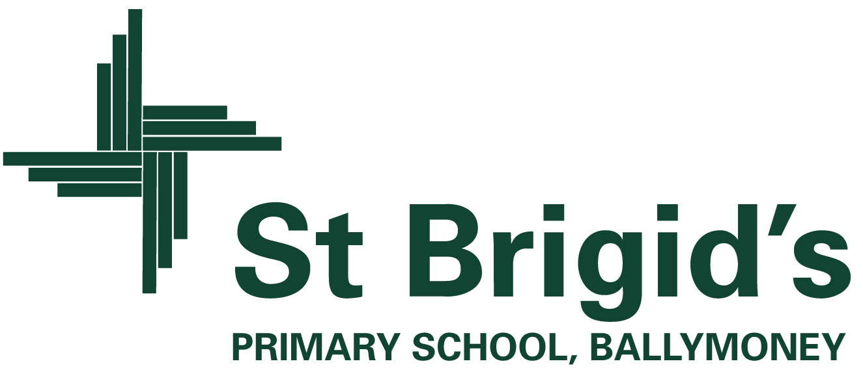

**Curriculum Newsletter Class B Term 1**