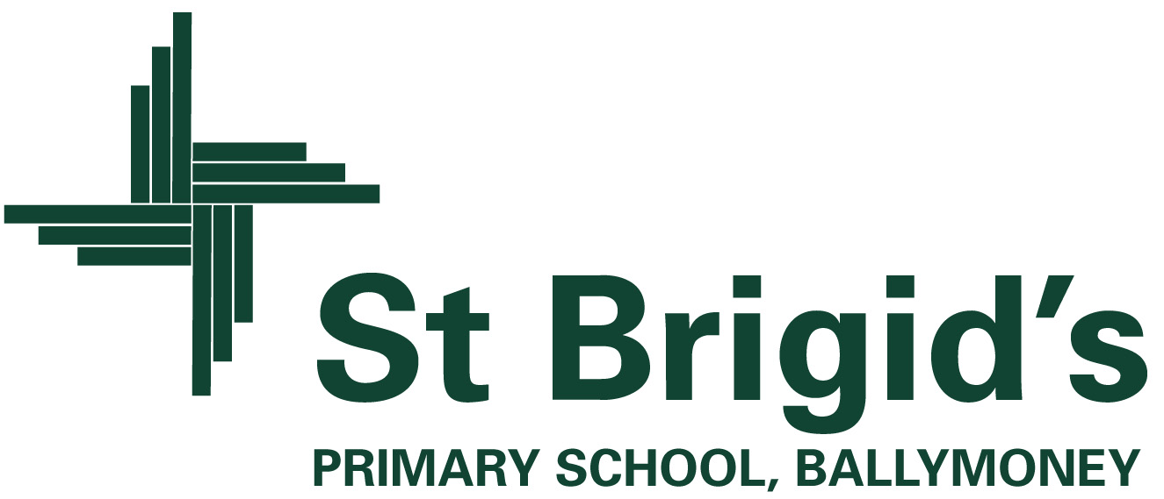

Curriculum Newsletter Class A Term 1

The World Around Us
(Science, Technology, Geography and History)

Our current theme for this term is ‘Wonderful Me!’

Within our World Around Us topic this term, we have been exploring elements of ourselves. We have started off by identifying our own features such as hair/eye colour, height and age. We discovered, regardless of how similar or different these features are to others, each and every one of us is very unique, special and important. We will extended this to look at our qualities and attributes and we will write our own poems using the information we will collate. With reference to our shared reading story ' Snow White and the Seven Dwarves ' we will explore the different characters of the Wicked Queen and Snow White to structure descriptive writing and we will compare these character profiles. To add a creative element to this we will then be adding a new dwarf to the story. We will get the opportunity to name and customise this dwarf however we would like.

In addition to focusing on what we are like, we will be investigating how we can look after ourselves and keep healthy. We will be identifying ways in which we can keep healthy such as getting plenty of sleep, eating healthy foods, exercising, keeping clean and brushing our teeth. We will make this relevant to the children by connecting to their own experiences and then build on this by introducing 'Sally,' the baby, to highlight the importance of leading a healthy life. Play experiences will reinforce this as the children will get the opportunity to bath, play with, dress, feed, and look after baby. At all times the children will be able to relate to their own lives and language and ideas will be developed though this. Our role play area is currently a doctors’ surgery which is going down a treat…there is lots of dressing up, medical diagnoses and treatments being discussed and the children are applying their knowledge, past experiences and new learning to communicate with the adults and peers.

As our topic progresses, we plan to look specifically at our bodies and define the names of different bones. We will explore the purpose of an x-ray and will seek to identify which parts of the body are on display through looking at x-ray images. This will lead nicely into Hallowe’en (skeletons, skulls and bones) and we will partake in songs to make this fun for the children. Naming and looking at the purpose of main organs will help the children to come to an appreciation of how important their bodies really are and why and how we should look after them.

Alongside this learning we will be investigating our changing world and will be welcoming Autumn changes. We hope to get ‘out and about’ and we will keep you informed of any outings that we may be going on. Attention will move towards Hallowe’en and we will be having lots of fun through this. The children are already talking about this!!

We are off to a good start this year. There will be lots of fun teaching and learning ahead! Let’s hope it is a good year.

Included in themed work are creative activities, simple science investigations, activities which explore our environment and activities which use information technology.

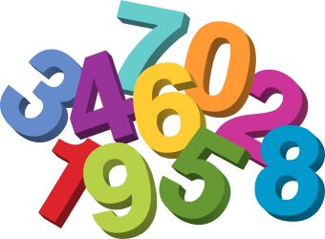
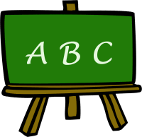
What else is happening in the curriculum?

Using ICT
The children will be encountering a range of ICT activities throughout our topic. They will be able to watch and interact with the stories using a variety of different websites. Our UICT task this month will require the children to design a new dwarf for our story ‘Snow White’. They will draw, name and add a photograph to their work in the SketchBook App.

Maths
In maths we will be working at the following:
- Sorting objects.
- Copying patterns.
- Number 1-10 (counting and making sets).
- Basic shape.

What’s going on?

Class A will be exercising and keeping active throughout the day in many ways
- play based learning sessions
- ‘wake and shake’ in the morning
- brain breaks throughout the day
- the ‘daily mile’
- sensory sessions in the morning
- PE sessions (Class A and integration where possible)

We also encourage healthy snacks at break time.

We will visit our school library on a Monday and Wednesday where we get to explore a wider variety of books and even take one down to the classroom to keep in our ‘work box’ for other times we get a chance to read it. We hope to visit Ballymoney Library this year and it would be lovely if this was something that you also get to do with your child.

We also have plans to enhance our topic work with some local visits….we will update you as these are confirmed.

