
Curriculum Newsletter P7 Term 1


The World Around Us
(Science, Technology, Geography and History.)
Our theme for this term is ‘Dream Machines’.
This study will allow the children to research and find out about how machines of today were invented, why and by whom. This will include transportation, electrical equipment, phones, cameras, etc, and we will produce a timeline of different machines, for example, the car, train, boat, aeroplane, comparing and contrasting ‘old’ and ‘new’/ then and now. The children will work in small groups to plan and execute an oral presentation of their research.

The children will investigate, analyse and discuss the usefulness and ingenuity of ‘everyday inventions’. We will look at ‘gadgets’ or ‘clever inventions’ (not electronic) that might be found around our homes, in school and within our community.
We will also look at what types of products are produced by machines today and set up a production line in our classroom to create a card for Christmas to give the children an understanding of how factories work and how every single part of that line is essential and important.

The children will paint a robot with a focus on shading and shadow and invent a name for it, detailing its special features and abilities. They will make a 3D model of a robot, so they can begin to gather up some recyclable materials for this art project. I will let the children know when these materials should be brought into school.

Our theme will also incorporate other creative and imaginative activities. The children will be asked to make up their own ‘machine of the future’ which can do something imaginative, spectacular and innovative. They will be given the opportunity to produce a design of their invention, create its control panel and present and explain their ideas to the rest of the class.
Within their creative writing, they will write about their own ‘dreamland’, using Roald Dahl’s ‘Charlie and the Chocolate Factory’ as inspiration.

We will learn about mechanisms such as pulleys, levers, wheels, springs, hinges and cogs through scientific investigation, planning, setting up, carrying out fair tests and recording and analysing results.

In poetry writing, the children will design and produce their own composition of ‘Machine Mayhem’. They will use their previously learnt and practised skills of writing poems to complete this work in Literacy.

Included in themed work are creative activities, simple science investigations, activities which explore our environment and activities which use information technology.

What else is happening in the curriculum?

ICT

The children will undertake ICT tasks to continue to develop their basic computer skills. Pupils will create a poster using Microsoft Word to present their research and findings about their chosen machine, downloading, editing and formatting pictures, and opening and organising folders to save their work.
We will use Mathletics for online Maths homework on a Wednesday and children will require access to the internet for various online homeworks -more info on this to follow.
Maths
Among the Maths topics we will be covering for this term, the children will be studying Shape and Space (including 2D and 3D shapes, their properties and ways of sorting them using Handling Data) and Fractions, Decimals and Percentages as well as Money.
We will also take an in depth look into Time, including lengths of journeys within the 12 and 24 hour clock, and analysing timetables.
We will also focus on the Mental Maths Strategies of partitioning, reordering, rounding & adjusting and inverse operations this term.
Mental Maths strategies will be a key focus throughout the year.
Literacy
The children continue to use cursive script in their handwriting. Here are some examples of this style of writing:
Sonny the slimy snake slithers and slides in the sun.
We are encouraging the children, alongside their Guided Reading and Accelerated Reading books, to read novels of their own choice for enjoyment and to help support the Guided Reading work undertaken in school.

We will continue to focus on poetry writing, using as many opportunities to get outdoors to inspire our writing.

Spellings will be worked on in class until formal homework begins.

What’s going on?

Dream Machines
As part of our research about machines of the past and of today and for their mini projects, it would be beneficial for the children to have access to good research materials at home. This could be in the form of internet access, books or talking to people who have valuable information and experiences to share with the children.
The children will be making 3D models of different machines, as well as designing and making control panels for their clever invention.
P.E.
Primary 7 will have council-led hockey for P.E. on a Wednesday. Children should bring PE gear into school on this day. Further PE times will be communicated soon.

Homework
As well as learning spellings, the children will be expected to find out meanings of words. Alongside their Friday spelling test they will be asked to use each word in the correct context within a correctly punctuated sentence which they will prepare at home. Reading homework is of paramount importance as this will have a positive effect on your child’s formal skills of spelling, punctuation and grammar and also their creative writing skills. The children will receive their guided reading book on a Monday, giving them time to have their book read and prepared for our guided reading lesson on a Thursday.
AR books are chosen in school and the children will continue to complete quizzes in school, striving towards their accuracy and points targets.



Primary 7 worked together to produce our Class Contract. We all contributed suggestions and ideas for useful and manageable guidelines for us to work and play by. Here is the final list that we all agreed on.
Our Class Contract

Think for yourself

Homework - Don’t Forget!

Deal with issues appropriately

Be helpful, kind, responsible and independent.

Drama is for the stage!

Have fun and work hard!

Be respectful to everyone and our resources.

TRY YOUR BEST!

And remember...green is good!

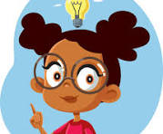

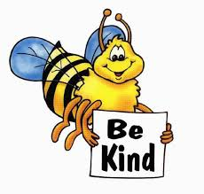
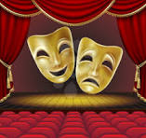



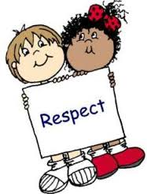
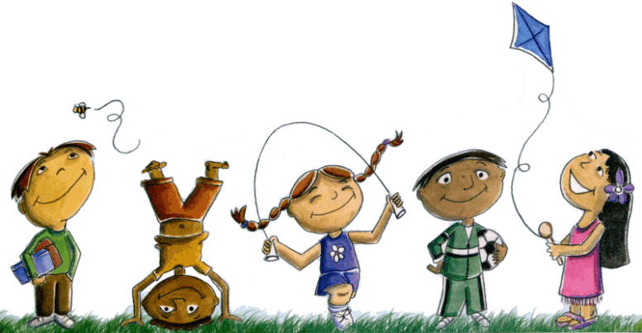

Signed ______________________________________________

