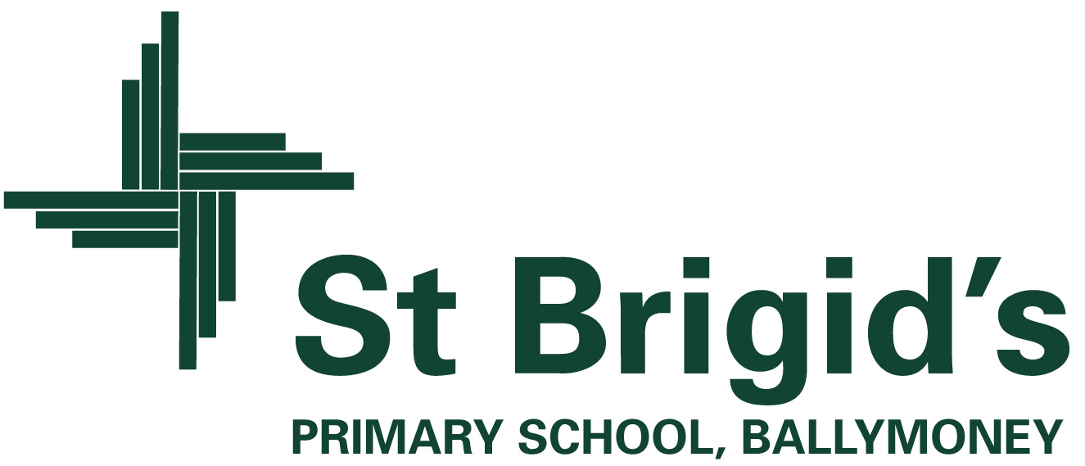

**Curriculum Newsletter P4 Term 1 2023**

The World Around Us

(Science, Technology, Geography and History.)

During **September**, the topic for P.4 is called “Wonderful Me.” 

We will be looking at the area of healthy eating, good hand washing and hygiene habits, the importance of exercise in our lives and having a balanced diet. Activities will involve sorting food items into different food groups and playing ICT games in ABL to investigate and reinforce the importance of keeping our bodies healthy and having a balanced and varied diet.

Science experiments will be carried out to help the children explore their senses and we will be discussing and celebrating how we are all unique and special. Using ink blocks, we will capture our fingerprints and use our knowledge of the different line patterns to ‘solve a serious crime’ within the P4 classroom!



From **October to December**, the P.4 topic will be “My Place and Yours.”

This topic will include a detailed study of Ballymoney Town.

We will be looking at the position of our school and town in relation to the world, the U.K, and within Ireland.

The children will produce a video advertisement to promote life in Ballymoney which they will then share with their peers in class.

In their WAU project they will include information and pictures about their local area and design factual travel brochures advertising local buildings and areas of interest in the town. To aid this work, the children will go on a ‘trail’ around the town, where they will take photographs and record short video clips.

Included in themed work are creative activities, simple science investigations, activities which explore our environment and activities which use information technology.

Homework

Children will receive homework each night with the following structure:

* Monday- spelling based activity (one unit, 2 pages per week). Copy out Monday spellings into homework diary. Guided Reading (15 minutes)
* Tuesday- Maths based activity (2 pages)

Copy out Tuesday spellings into homework diary. Guided Reading (15 minutes)

* Wednesday- English in practice workbook (2 units) OR phonic based activity. Copy out Wednesday spellings into homework diary. Completion of Guided reading book.
* Thursday- Mathletics activity (every 2nd week) **OR** WAU/ R.E based activity. Revision of all spellings in preparation for Friday spelling test in school.

**Guided Reading:** The children will be given a new reading book every Monday. They will complete a guided reading task on this book in school every Thursday.



What’s going on?

**Seesaw:** During week one, your child was issued with a password to access the Seesaw learning app from home. Seesaw will be used in P4 as a way to communicate with parents and to keep you up to date with what is happening in P4.

**PE** : Sessions are still to be confirmed – this information will be shared via Seesaw.

Children will be changing for PE in school and therefore need to bring a t-shirt / joggers or shorts as well as PE trainers to school on both these days.

PLEASE ENSURE ALL ITEMS ARE CLEARLY MARKED WITH YOUR CHILD’S NAME.

**Break**: We are a ‘Healthy school’ and we operate a healthy break policy. Pupils are asked to have a small healthy break and mini-break snack each day e.g a piece of fruit or a pancake.

**Weekly Tests:** On a Friday, the children will have a weekly spelling test and a short maths test focussing on their topic for the week. Results of both tests will be uploaded via Seesaw on a Friday afternoon.

