MC900232110[1]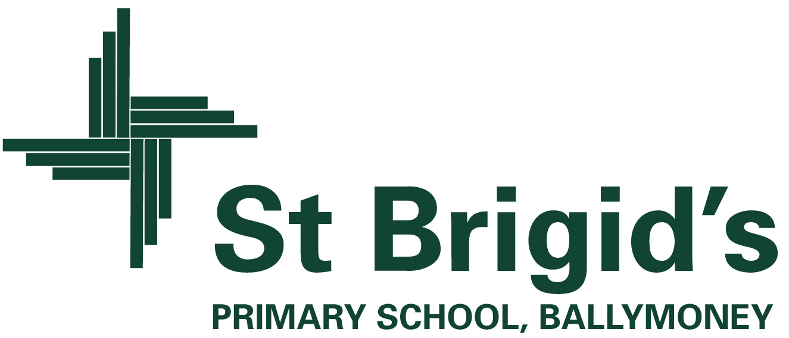

**Curriculum Newsletter P2 Term 1 2023**

The World Around Us

(Science, Technology, Geography and History)

The theme we are studying at the beginning of this term is ‘**Wonderful Me’.**

The focus of this topic is to help the children gain a greater understanding of ‘Ourselves’, our bodies and how to care for them. We have an exciting few weeks ahead of us in P.2! We will be busy learning about our senses, carrying out experiments based on investigating the role they play in our daily lives. This topic has already led us to looking at our unique characteristics e.g. hair colour and eye colour. We will write facts about our body and will discuss our uniqueness by looking at our fingerprints and focusing on our talents. We will be considering adjectives to describe ourselves and will discuss what makes us special. We will have hospital role play equipment set up in the classroom for play based learning and we will be re-enacting the roles of patients, doctors and nurses. Any parent who works in the healthcare profession who would like to talk to the class about what they do would be very welcome to share their knowledge with our class.

Our Topic will change to “**Yum, Yum**” in the second half of the term. The children will investigate the importance of having a healthy and balanced diet. We will look at different types of food, sorting them into what we think we should eat most or least often and we will be investigating the hidden sugar content in foods and drinks. This topic will allow huge potential for investigation and research. For example, we will be looking at the importance of storing food in the correct place and we will be studying food labels to discover where in the world our food comes from and mapping the journey it makes before arriving on our plates!

***We will be really busy bees!***

Included in themed work are creative activities, simple science investigations, activities which explore our environment and activities which use information technology.

***What else is happening in the curriculum?***

Homework: Homework will be sent home on a Monday and the red homework folders will not need to be brought into school until they are due for return each Friday morning. Our P2 homework will be presented in a short A4 booklet with spellings, reading log, homework activities all within the one booklet to make it more manageable going between home and school. This booklet will be marked when brought in on a Friday and will then be sent home for you to keep. We will continue to use the Seesaw App to assign various homework activities to your child throughout the school year. Two reading books will be given each week. The spelling of sounds or rhyming words and tricky words will be tested each Friday based on the given set assigned.

ICT: Children will program Beebot robot to move around the supermarket mat using a series of instructions. They will use the Sketchbook app to draw a portrait of themselves and the ipads and computers to engage in Literacy and Numeracy activities on a daily basis.

Numeracy: We will be working on identifying numbers 1-30 and beyond as well as beginning to look at adding and subtracting. This will lead us onto exploring number stories and bonds to 10. We will be naming odd/even numbers and using money to 50p: 1p, 2p, 5p, 10p, 20p, 50p. Pattern, sorting, shape and data handling work will be revisited throughout the term.

P.E: Children will enjoy P.E. on Monday and Thursday. On these days, please send your child to school wearing their P.E. shoes.

**What’s going on this term?**

P.2 will be getting busy inside and outside the classroom! We will get outdoors to explore the changes ‘Autumn’ brings as well as going on various adventures in order to use each of our 5 senses in our surroundings. We will be grasping opportunities to use the outdoor classroom for play based learning.

**Class Contract**

In order to secure a happy and safe learning environment P.2 has agreed upon the rules (overleaf) which we have devised together. You will notice that these are presented in a positive ‘We can’ way. We will strive to achieve them and succeed in keeping them. Children will be awarded ‘Green Cards’ when they work well and conscientiously adhere to the rules. There will also be ‘Superstar Points’ awarded to each table whenever they work well together as a team. The ‘Green Card Winner’ will be rewarded on a Monday so that it is reset for the week ahead. The table of the week will be rewarded each Friday and they will choose their reward so this will vary. The children are already enjoying watching their green cards accumulate! Another lovely surprise at the end of each week will be our Principal’s Award. This child’s achievements and positive character will be recognised each Friday as their success is celebrated alongside the entire school. and they will be awarded a certificate.

MC900250922[1]

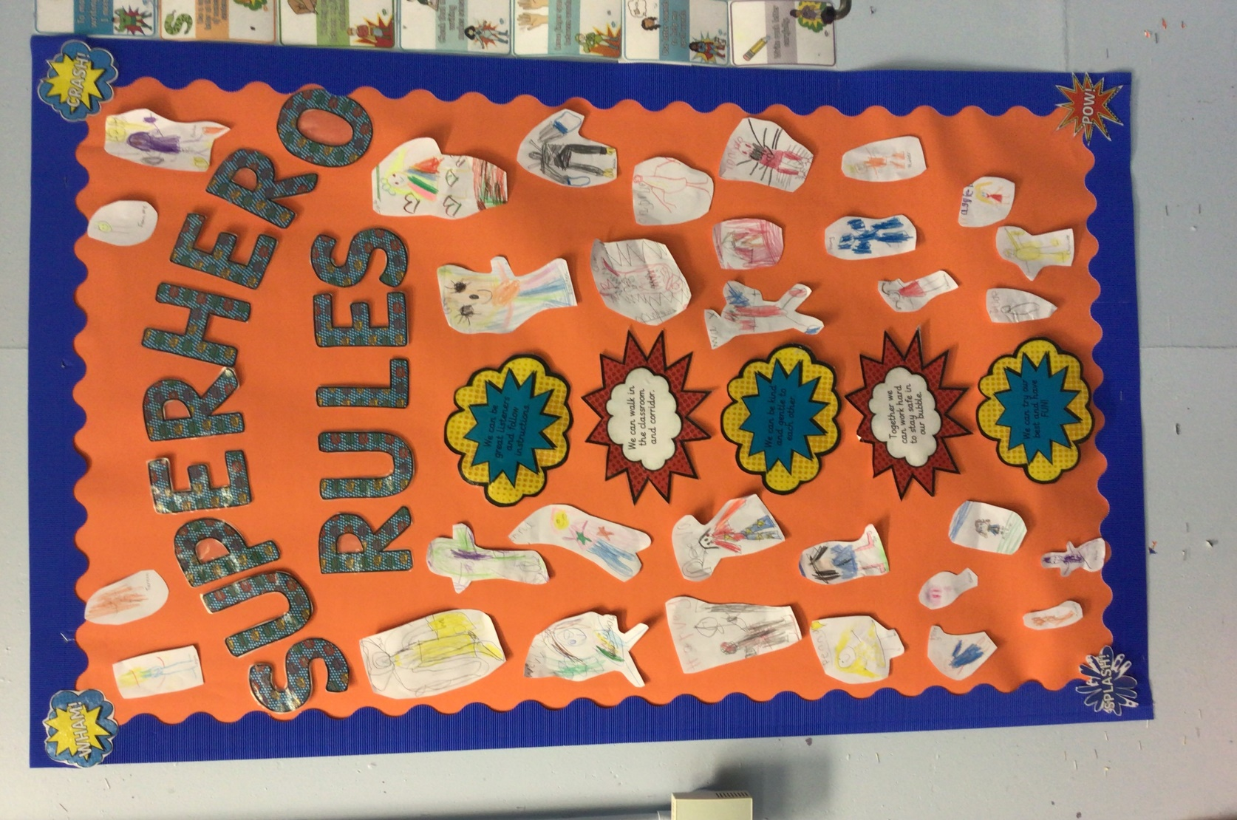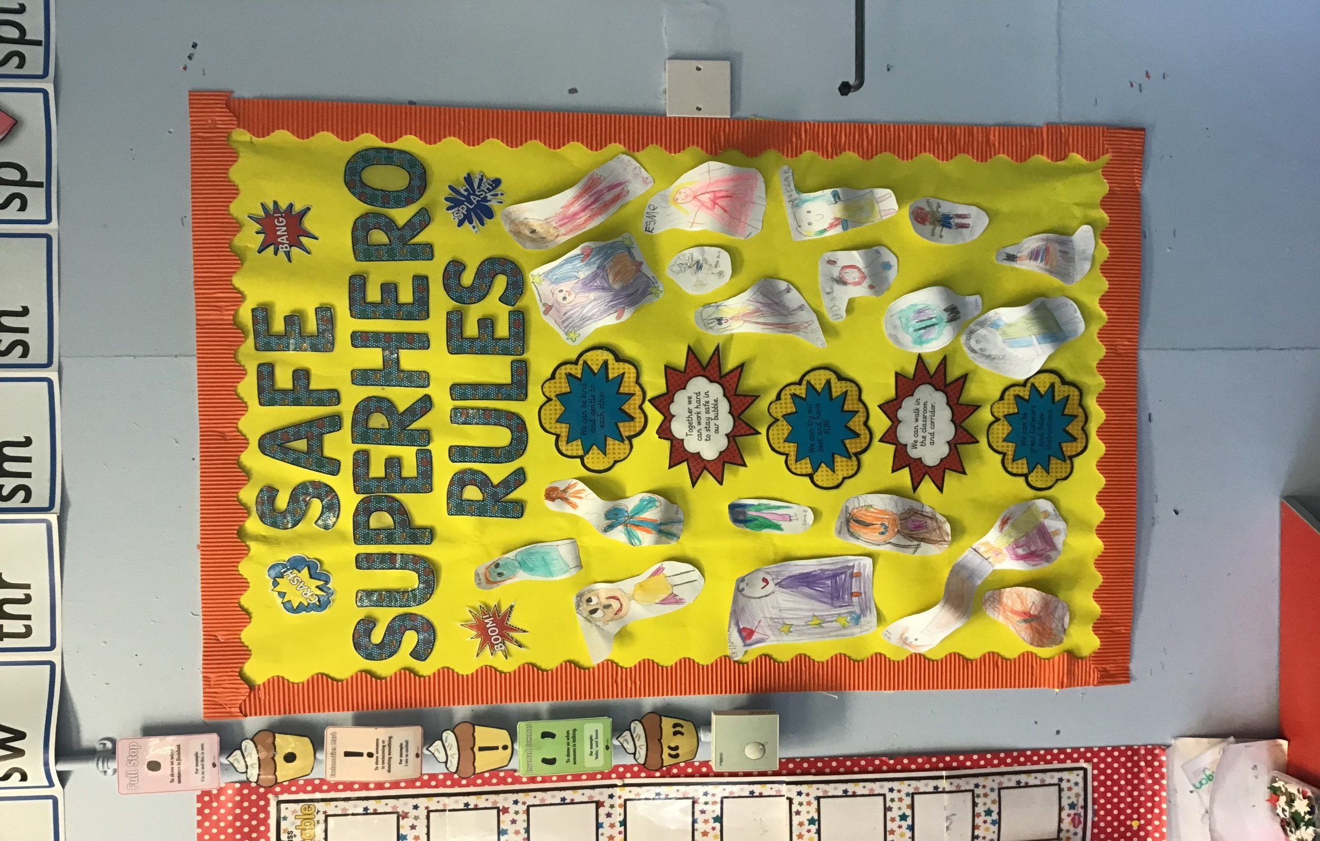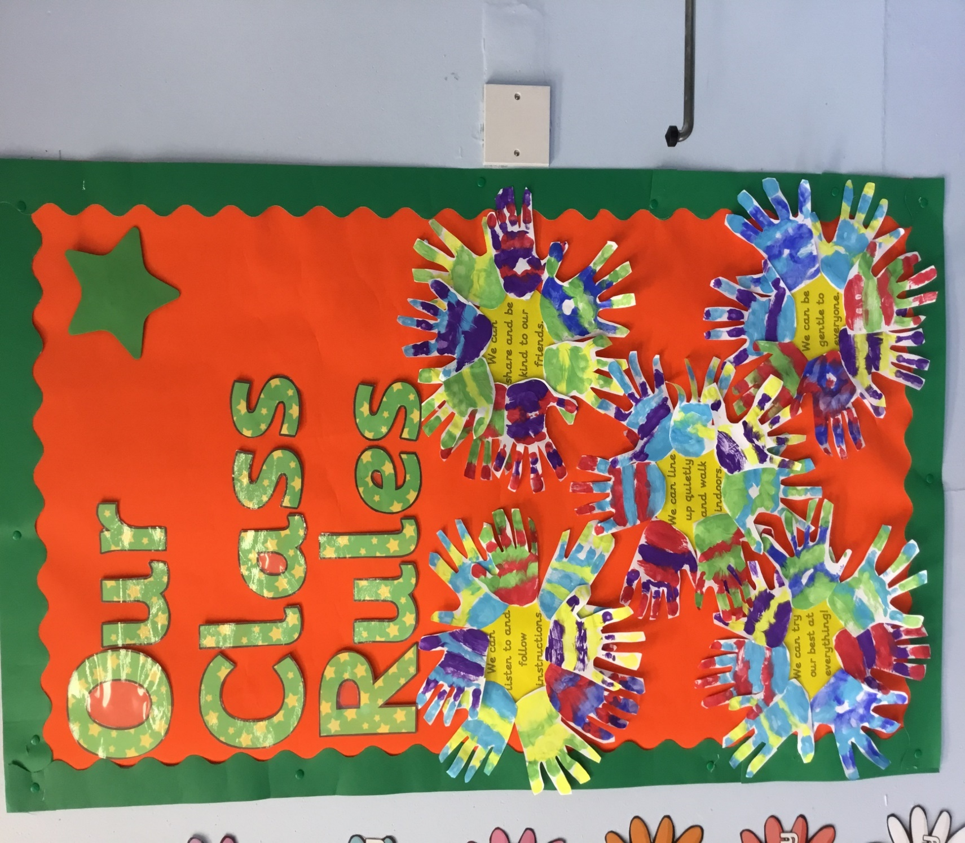

* We can be kind and gentle to each other.
* Together we can work hard to keep safe.
* We can be great listeners and follow instructions.
* We can walk in the classroom and corridors.
* We can try our best and have FUN!

***OUR PLAYGROUND RULES***

* We can be a great friend.
* We can be gentle.
* We can follow instructions.
* We can play nicely.
* We can line up quietly.

MC900250922[1]

In the playground, we will make a special effort to include everyone in our games and will always aim to be kind and gentle to those around us.

*[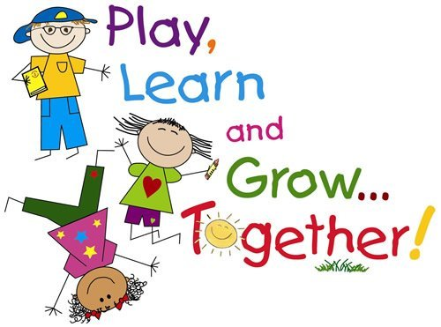](http://www.google.co.uk/url?sa=i&rct=j&q=&esrc=s&source=images&cd=&cad=rja&uact=8&ved=0CAcQjRxqFQoTCIv7tO6vjcgCFSGt2woddogPIA&url=http://www.mpsaz.org/sirrine/educational_links/&psig=AFQjCNEs3_Wd2RgLYl-A9R6eLV6cPXDzBQ&ust=1443105165988514)*

**Our class motto in P2 is: “We can!”**

MC900250922[1]