World Maths Day 2020 Parents’ Problem Solving Competition

Name_______________________Child’s Name_____________Class______

If Thursday is two days before the day after tomorrow, what day is the day before yesterday?

­­­­Answer:_____________________________

­­­­How many triangles can

you see?

Answer:________________

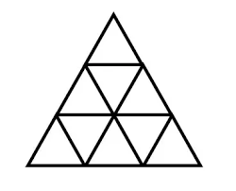

­­­­

Answer: _________

[](https://www.google.co.uk/url?sa=i&url=https://lovesharego.com/test/very-interesting-maths-riddle-answer-in-the-description&psig=AOvVaw3VJzJfrvTfXmnDk5aCnhDs&ust=1582882405824000&source=images&cd=vfe&ved=0CAIQjRxqFwoTCJCbqs628ecCFQAAAAAdAAAAABAL)

There are seven gears connected in a row, the first one is connected to the second one, the second one is connected to the third one, and so on.   
If the first gear is rotating clockwise what direction is the seventh gear turning?

Answer:_______________



[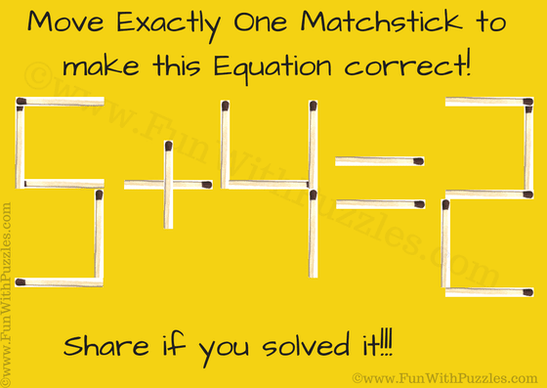](https://www.google.co.uk/url?sa=i&url=https://www.funwithpuzzles.com/2018/12/simple-matchstick-math-riddle-and-answer.html&psig=AOvVaw3VJzJfrvTfXmnDk5aCnhDs&ust=1582882405824000&source=images&cd=vfe&ved=0CAIQjRxqFwoTCJCbqs628ecCFQAAAAAdAAAAABAE)

­­­­

Show by inserting arrows on the sum.

[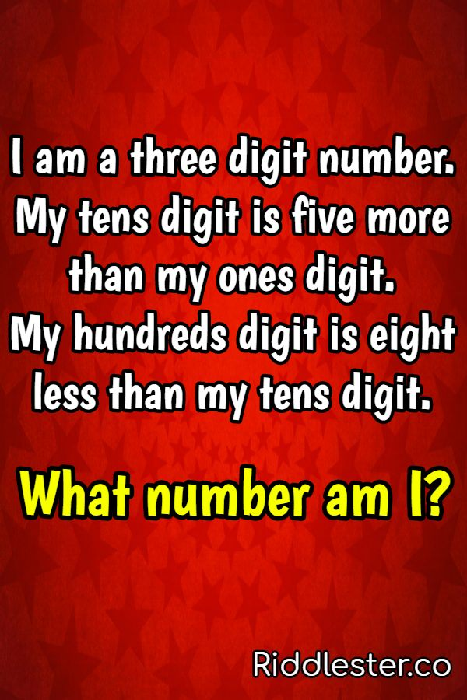](https://www.google.co.uk/url?sa=i&url=https://www.riddlester.co/25-tricky-riddles-for-kids/&psig=AOvVaw1v8Db-rmCqcRs7qkkl52Hy&ust=1582883524646000&source=images&cd=vfe&ved=0CAIQjRxqFwoTCNCzpOS68ecCFQAAAAAdAAAAABAE)

­­­­

Answer:________________

­­­­Find the weight of

each animal.

Answer: _______________________

[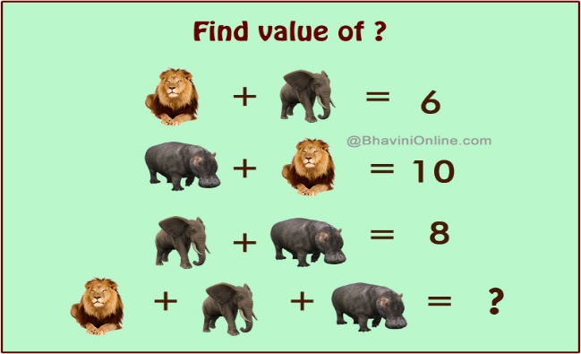](https://www.google.co.uk/url?sa=i&url=https://www.bhavinionline.com/2016/01/fun-math-riddle-lion-elephant-hippo/&psig=AOvVaw3VJzJfrvTfXmnDk5aCnhDs&ust=1582882405824000&source=images&cd=vfe&ved=0CAIQjRxqFwoTCJCbqs628ecCFQAAAAAdAAAAABAa)

Good luck and enjoy!!!