

**School Information for Parents/Guardians**

**Monday 25 November 2024**

Follow us now on **the web** for news updates

**www.stbrigidspsballymoney.com**

Save the Date!!

ST BRIGID’S PS - OPEN MORNING

**Registration P1 September 2025**

Tuesday 26 November @ 10 am

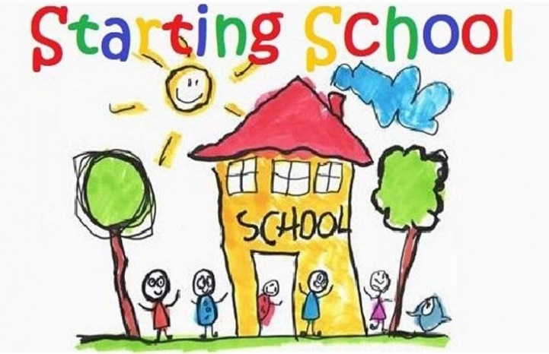

**Sunday 24 November**

* Year 4/Holy Communion children - Do This In Memory Mass 9.30am in Chapel

**Monday 25 November**

**December Milk**

**£2.95**

**Order before Tuesday 26 November**

* Dinner menu Week 4 – for details see school website.
* Violin Tutor in

**Tuesday 26 November**

* Guitar Tutor in
* Open Morning 10am
* **Swimming Class B (1.00-1.30pm) and Year 5 (1.30-2.00 pm) £3.50 per week**

**Wednesday 27 November**

* Payment due for trip to the pantomime – Aladdin (£14.50 per pupil)
* **Year 5,6 & 7- Leid Week – Ulster Scots Workshop**

**ASDA CASHPOT**

**FOR SCHOOLS**

**Amount raised so far**

**£200.46 Thank you**

* Year 5/6/7 & CB – Gaelic Skills
* Singing Tutor in

**Thursday 28 November**

* Year 5 & 6 Game Changers Programme

**Friday 29 November**

* Y4 and CB visiting Ballymoney Museum – Causeway Safari Exhibition
* Piano Tutor in
* Principal Assembly
* Football 2-3pm (Y6 & 7) £1 per week

**Up and coming information & dates for your Diary**

* **Christmas Break 2024:**

12 noon Friday 20 December – Friday 3 January (inclusive)

Have a very enjoyable weekend and thanks for your continued support.

Mr K O’Neill Principal

**St Brigid’s Primary School – Castle Street – Ballymoney – BT53 6JX – 028 27662664**



**School Trip to the Riverside Theatre**

**Aladdin**

Tuesday 3 December 2024

Whole School

**Cost £14.50 per pupil**

Payment can be made in instalments to spread the cost over next 10 weeks. Payments can be made at any time. Just send money into the school clearly marked for the attention of the class teacher.



**PTA Grand Christmas Draw Prize Donation**

**Appeal 2024**

If you feel you can support us please contact Susan in the main office.

Further information about the tickets will be issued shortly.

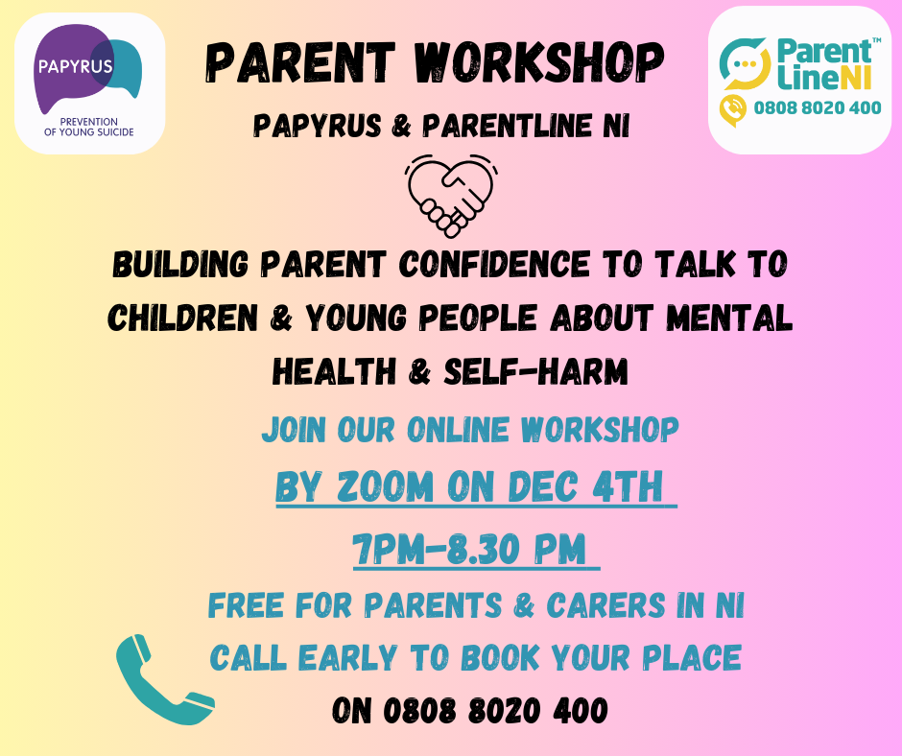

**NUT FREE SCHOOL**

**St Brigid’s PS is a Nut Free School. There is a child in our school with a Nut Allergy.**

**Please do not send in Nuts or Nut Spreads to school.**

**Registration P1 September 2025**

**If you have a child starting school in September or know someone who is, please contact the school to register your interest.**

Phone: 02827662664

Email:  [**info@stbrigidsps.ballymoney.ni.sch.uk**](mailto:info@stbrigidsps.ballymoney.ni.sch.uk)

Application process is online this year and opens on 10 January 2024 at 12noon (GMT) and closes on 24 January 2024 at 12noon

**Christmas Show**

**Save the Date!!**

**Year 1-3 & Class A Show**

**Thursday 12th Dec @ 10am**

**Tickets go on sale from**

**Monday 2nd December**

**(2 per family per show)**

**Tickets £5 each**