

**School Information for Parents/Guardians**

**Monday 24 June 2024**

Follow us now on the websitefor news updates.

[**www.stbrigidspsballymoney.com**](http://www.stbrigidspsballymoney.com)

**Another successful school year at St Brigid’s.**

As we come to an end of another school year may I begin by thanking you all for the commitment and dedication you have given throughout this school year to support your children and the school. The children have worked extremely hard all year and they deserve a well-earned summer break. A massive thank you to all the staff in St Brigid’s who provide amazing support, care and dedication to all the children. St Brigid’s success is the sum of all the parts working together. I will be in touch at the end of August with up-to-date information about reopening for the new school year. The most important date to know at this stage is that school will restart on Friday 30 August 2024.

I hope that you all have a lovely summer break and that we have some good weather to enjoy it.

Take care and keep safe. Mr O’Neill & Mrs Campbell.

**Monday24 June 2024**

* Dinner Menu – **See information**
* Leavers’ Mass 1.00pm in the Church followed by refreshments in the school and Leavers’ Assembly
* Year 7 pupils last day
* **School Closes for all pupils at 12.30 pm**
* **No After School Club today**
* Breakfast club as normal

**Thursday 27 June 2024**

* Last day for Class A & B

**Friday 28 June 2024**

* School closes 12noon
* No school meals
* No After School Club

**Dinner Menu Changes**

**Monday 24 June**

Golden crumbed fish fingers, baked potato & veg, flakemeal biscuit

**Tuesday 25 June**

Bolognaise, pasta & veg

Sticky toffee pudding

**Wednesday 26 June**

Hot Dogs, corn on cob, potato wedges

Summer cheesecake

**Thursday 27 June**

Party Box: Cocktail sausages, chicken goujons and chips & Ice lollies/ice cream





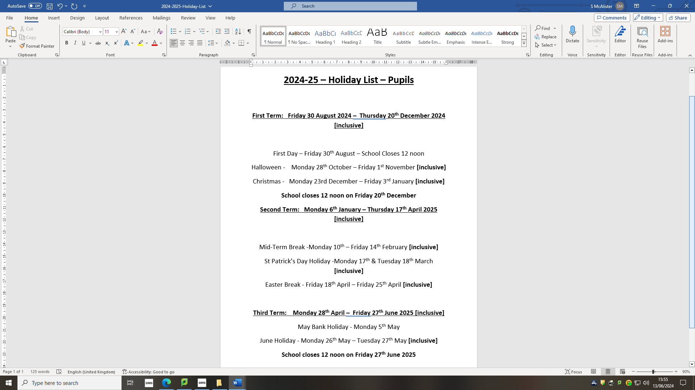

**After Schools Club**

Please pay all invoices before Friday 28th June.

Any casual Sunshine Club users **must** book and pay on the day.

**Leavers’ Mass**

The Year 7 Leavers’ Mass will be on Monday 24June at 1.00 pm in Our Lady and St Patrick’s Chapel.

The children and parents will return to school after Mass for refreshments and a Leavers’ presentation.

The school will close at 12.30 pm on this day for all other classes to allow staff to attend the Leavers’ Mass.

This will be the last day of school for the Year 7 pupils.



**Return to School 2024-25**

**The school will reopen on Friday 30 August for a half day (9.00 – 12 noon).**

This is to facilitate Child Protection and Safeguarding Training for all staff in the afternoon. There will be no Breakfast or After School Clubs on Friday 30. School meals and transport will begin on Monday 2 September.

**A full school day for all children will commence on Monday 2 September. All after school facilities will be available from this day.**

**P1 children will finish at 12 noon for month of September**

All the new children in Year 1 and Class A will have been issued with a specific start date.





