

**School Information for Parents/Guardians**

**Monday 21 October 2024**

Follow us now on **the web** for news updates

**www.stbrigidspsballymoney.com**

**Parent Interview Week 21-25 October**

**School will close each day this week at 1.00pm.**

**Due to the yellow bus having to deliver school meals, it will not be available to collect children at 1.00pm when the school closes for parent interviews. Please make alternative arrangements to have your child picked up at 1.00pm each day this week (Mon-Fri).**

**There will be no CB or Year 5 swimming during this week.**

**The After School Club will be open as normal from 1 – 5.30 pm. Pre-booking only - no casual drop-ins.**

**Sunday 20 October**

**November Milk**

**£4.20**

**Order before Tuesday 22 October**

* Year 4/Holy Communion children - Do This In Memory Mass 9.30am in Chapel

**Monday 21 October**

* New Dinner menu Week 3 – for details see school website.
* Girls’ Hockey Blitz (am)
* **School Closes all week at 1.00pm for Parent Interviews**
* Violin Tutor in

**Tuesday 22 October**

* Guitar Tutor in

**ASDA CASHPOT**

**FOR SCHOOLS**

**Amount raised so far**

**£146.57 Thank you**

* Boys’ Hockey Blitz (am)

**Wednesday 23 October**

* Year 4 Multi-Sport: (5 weeks - £2.00 per week or £10.00 for 5 weeks)
* Year 5/6/7 & CB – Gaelic Skills
* Singing Tutor in

**Thursday 24 October**

* Halloween Disco Y1-3 6.15 – 7.15 pm and Y4-7 7.30 – 8.30 pm

**Please Note: This is not a Halloween Dress Up Disco**

**Friday 25 October**

**NUT FREE SCHOOL**

**St Brigid’s PS is a Nut Free School. There is a child in our school with a Nut Allergy.**

**Please do not send in Nuts or Nut Spreads to school.**

* **Halloween Fancy Dress Day**
* Halloween Dinner Special
* Piano Tutor in
* Football 2-3pm (Y6 & 7) £1 per week

**Up and coming information & dates for your Diary**

* **Mid Term Break October/November 2024:**

Monday 28 October to Friday 1 November (inclusive)

* **Christmas Break 2024:**

12 noon Friday 20 December – Friday 3 January (inclusive)

Have a very enjoyable weekend and thanks for your continued support.

Mr K O’Neill Principal

**St Brigid’s Primary School – Castle Street – Ballymoney – BT53 6JX – 028 27662664**

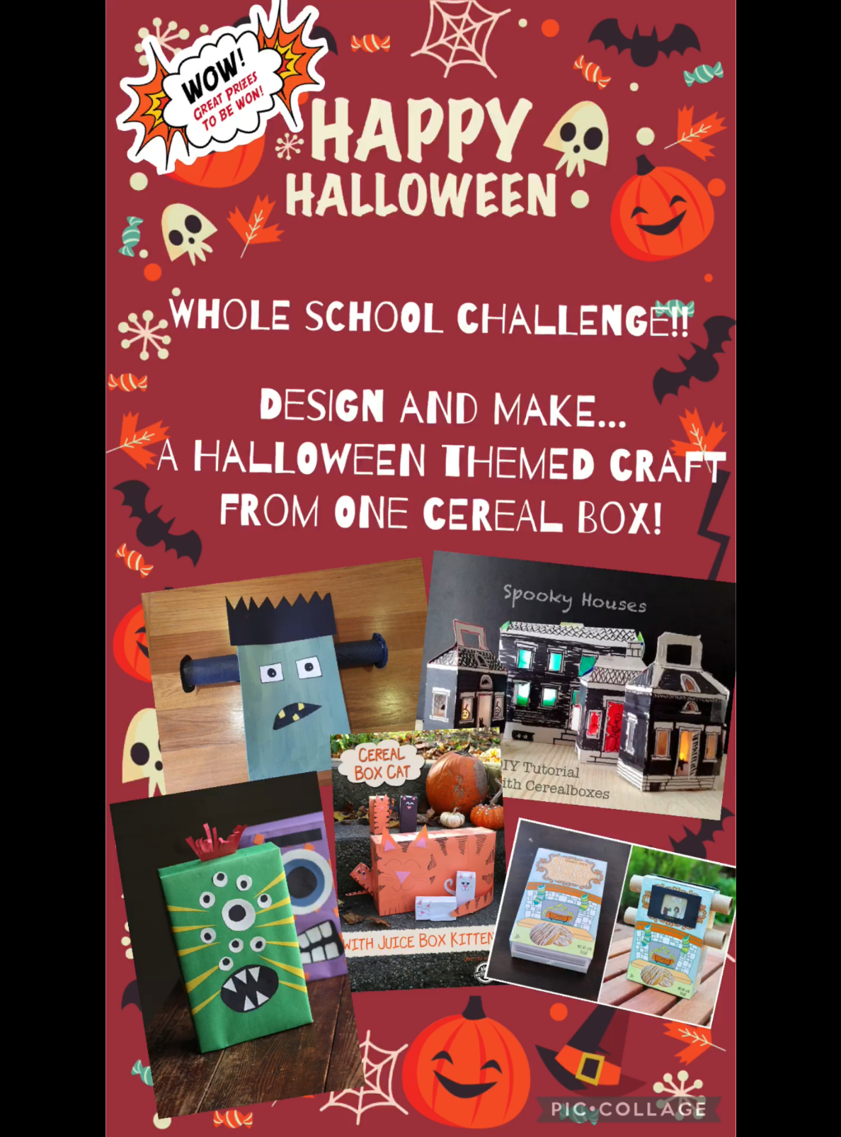

[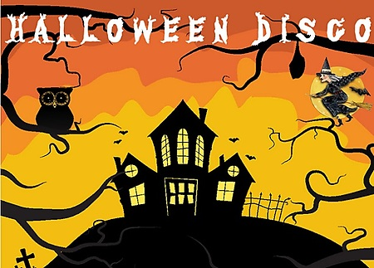](http://www.google.co.uk/url?sa=i&rct=j&q=&esrc=s&source=images&cd=&cad=rja&uact=8&ved=0ahUKEwiR-avVgMrWAhWHJVAKHaKiBXYQjRwIBw&url=http://www.newbridgememo.co.uk/en/whats-on/events/halloween-disco/&psig=AFQjCNHAIMpXn3tG9M1iFa_Wo9qCiUcmyA&ust=1506761094389910)

**Thursday 24 October**

**Normal Clothing – NOT FANCY DRESS!**

Y1-3 6.15 - 7.15 pm

Yr4-7 7.30 - 8.30 pm

**Cost £3 per pupil**

[](http://www.google.co.uk/url?sa=i&rct=j&q=&esrc=s&source=images&cd=&cad=rja&uact=8&ved=2ahUKEwiEnayCsajdAhXEK8AKHVmtCFUQjRx6BAgBEAU&url=http://www.katyisd.org/campus/HE/Pages/PTA.aspx&psig=AOvVaw2Pet2zGg8sjf3JuWqVy3kD&ust=1536392124057568)

**PTA Meeting**

It was agreed at the meeting that there would be a change to the events this year. The Christmas event will be replaced by a Summer Fair this year in June. There will still be a Christmas Draw and several other in-school Christmas events.

A form to indicate a willingness to help at events will be sent to all parents next week.



**School Trip to the Riverside Theatre**

**Aladdin**

Tuesday 3 December 2024

Whole School

**Cost £14.50 per pupil**

Payment can be made in instalments to spread the cost over next 10 weeks. Payments can be made at any time. Just send money into the school clearly marked for the attention of the class teacher.

**DO THIS IN MEMORY**

Year 4 Holy Communion Class

The first Do This In Memory Mass will be at 9.30am on Sunday October 20th. After Mass we invite all primary school aged children and their parents to join us in the parish hall for craft activities (and a cup of coffee for the parents!)

**Do This In Memory Sundays**

October 20th 2024

November 24th 2024

December 15th 2024

January 26th 2025

February 23rd 2025

March 16th 2025

April 13th 2025

June 22nd 2025

***All at the 9.30am Mass***