

**School Information for Parents/Guardians**

**Monday 20th May 2024**

Follow us now on the websitefor news updates.

**www.stbrigidspsballymoney.com**

**Monday20th May**

* **P1 and Class B off due to Industrial Action**
* Dinner Menu – Week 2
* Violin tutor in

**Tuesday 21st May**

* **P1 and Class B off due to Industrial Action**
* Swimming Class B (1.00 – 1.30) and Year 7 (1.30 – 2.00pm) £3.50 per week
* Guitar tutor in
* Loreto Taster Day P6

**Wednesday 22nd May**

**Thursday 23rd May**

* Change in Dinner Menu – Goujons, spaghetti hoops, fruit muffin.
* Singing Tutor in.

**Friday 24th May**

**School Closed 24th – 28th May inclusive. Re-open Wednesday 29th May.**

**Information & Dates for your Diary:**



**Third Term: Monday 8th April – Friday 28th June 2024 [inclusive]**

Staff Development Day Friday 24th May ( Pupils not in school today)

May Bank Holiday Monday 27th May – Tuesday 28th May **[inclusive]**

**P7 Leavers’ Mass 1pm Monday 24th June - School closes 12.30pm for Years 1-6**

**NUT FREE SCHOOL**

St Brigid’s PS is a Nut Free School. There is a child in our school with a Nut Allergy. Please do not send in Nuts or Nut Spreads to school.

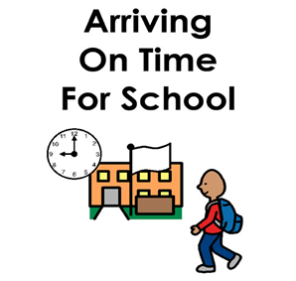

**SCHOOL TIME KEEPING**

Our school day begins at 9.00am and children should be in the playground by 8.45am to line up with their class for Registration. **Only children who arrive by taxi or bus should come into school via the front door.** Children attending Breakfast Club should also enter via the front door.

Research shows that children with consistent school attendance learn more. If children are to fully benefit from the many learning opportunities, regular school attendance is vital. A student who is 10 minutes late every day will miss 30 hours of instruction during the year, definitely, a significant loss in the teachable moments that you can’t get back.

|  |  |
| --- | --- |
| **Minutes late per day** | **School days lost per year** |
| 5 | 3 |
| 10 | 6.5 |
| 20 | 13 |
| 30 | 20 |

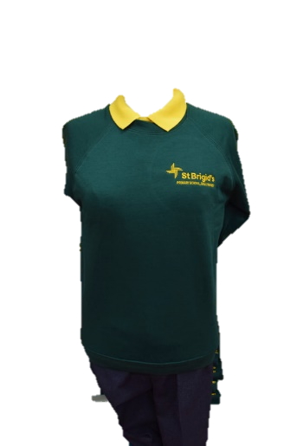



**SCHOOL UNIFORM**

Full school uniform should be worn each day:

* Yellow polo shirt
* Green school jumper/cardigan/Y7 hoodie
* Grey school skirt/trousers/shorts
* (No leggings or tracksuit bottoms)
* Green summer dresses can now be worn
* Trainers are also permitted this term

If your child is absent or being collected from school early for any reason, a note of explanation must be sent to the class teacher.

**Year 4 Sacrament of Holy Communion**

Saturday 1st June 2024 DO THIS IN MEMORY MASS – Sunday 2nd June (Corpus Christi).



