

**School Information for Parents/Guardians**

**Monday 13th May 2024**

Follow us now on the websitefor news updates

**www.stbrigidspsballymoney.com**

**Monday13th May**

* Dinner Menu – Week 1
* Violin tutor in

**Tuesday 14th May 2024**

* Swimming Class B (1.00 – 1.30) and Year 7 (1.30 – 2.00pm) £3.50 per week
* Guitar tutor in

**Wednesday 15th May**

* People who help us Year 1 visit from Fire Brigade

**Thursday 16th May**

* Singing Tutor in

**Friday 17th May**

* Principal Awards
* Gaelic Tournament – (Dunloy Academy)

**Information & Dates for your Diary:**

**Third Term: Monday 8th April – Friday 28th June 2024 [inclusive]**

Staff Development Day Friday 24th May ( Pupils not in school today)

May Bank Holiday Monday 27th May – Tuesday 28th May **[inclusive]**

**P7 Leavers’ Mass 1pm Monday 24th June - School closes 12.30pm for Years 1-6**

**Have a very enjoyable weekend and thanks for your continued support. Mr O’Neill**

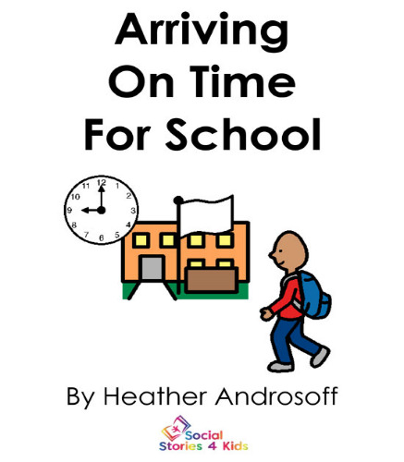

Our school day begins at 9.00am and children should be in the playground by 8.45am to line up with their class for Registration. **Only children who arrive by Taxi or bus should come into school via the front door.** Children attending Breakfast Club should also enter via the front door.

Research shows that children with consistent school attendance learn more. If children are to fully benefit from the many learning opportunities, regular school attendance is vital. A student who is 10 minutes late every day will miss 30 hours of instruction during the year, definitely, a significant loss in the teachable moments that you can’t get back.

|  |  |
| --- | --- |
| **Minutes late per day** | **School days lost per year** |
| 5 | 3 |
| 10 | 6.5 |
| 20 | 13 |
| 30 | 20 |



If your child is absent from school for any reason a note of explanation must be sent to the class teacher.

**AFTER SCHOOL CLUB**

Booking sheets must be submitted monthly via email: [**smcalister055@c2kni.net**](mailto:smcalister055@c2kni.net) or via hard copy sent into the school office. Bookings that are not cancelled will be charged for as booked. Children must be collected on time in-order-to avoid a £10 fine or additional hourly charge.

Breakfast Club open daily from 8am – 8.45 £2 per day

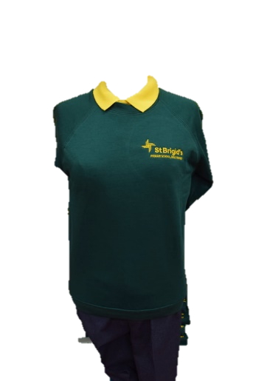

**SCHOOL UNIFORM**

Full school uniform should be worn each day:

* Yellow polo shirt
* Green school jumper/cardigan/Y7 hoodie
* Grey school skirt/trousers/shorts
* (No leggings or tracksuit bottoms)
* Green summer dresses can now be worn
* Trainers are also permitted this term



**Year 4 Sacrament of Holy Communion**

**Saturday 1st June 2024**

**DO THIS IN MEMORY MASS –**

**Sunday 2nd June (Corpus Christi).**

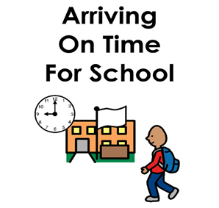

**NUT FREE SCHOOL**

St Brigid’s PS is a Nut Free School. There is a child in our school with a Nut Allergy. Please do not send in Nuts or Nut Spreads to school.