

**School Information for Parents/Guardians**

**Monday 11 November 2024**

Follow us now on **the web** for news updates

**www.stbrigidspsballymoney.com**

Save the Date!!

ST BRIGID’S PS - OPEN MORNING

**Registration P1 September 2025**

Tuesday 26 November @ 10 am

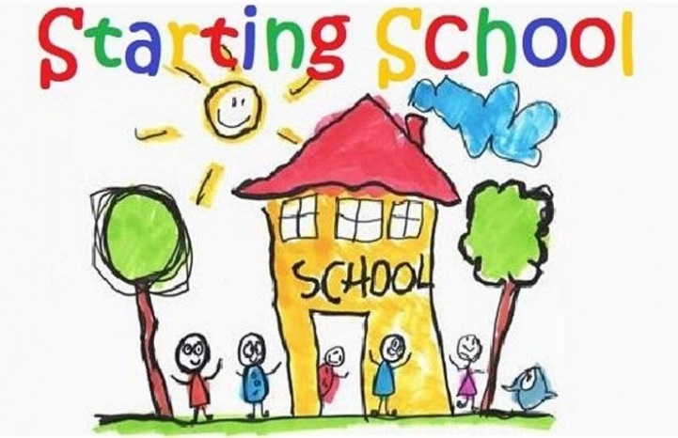

**Monday 11 November**

**NUT FREE SCHOOL**

**St Brigid’s PS is a Nut Free School. There is a child in our school with a Nut Allergy.**

**Please do not send in Nuts or Nut Spreads to school.**

* Dinner menu Week 2 – for details see school website.
* Violin Tutor in

**Tuesday 12 November**

* Guitar Tutor in
* Doherty Cup Match v Ballysally 1.15pm @ University
* **Swimming Class B (1.00-1.30pm) and Year 5 (1.30-2.00 pm) £3.50 per week**

**Wednesday 13 November**

* Year 4 Multi-Sport: (5 weeks - £2.00 per week or £10.00 for 5 weeks)
* Year 5/6/7 & CB – Gaelic Skills
* Anti-Bullying Art Workshop KS1
* Indoor Camogie Blitz in Cross and Passion, Ballycastle (pm)

**ASDA CASHPOT**

**FOR SCHOOLS**

**Amount raised so far**

**£177.05 Thank you**

* Singing Tutor in

**Thursday 14 November**

* Anti-Bullying Art Workshop KS2

**Friday 15 November**

* Piano Tutor in
* Principal Assembly
* Liz Weir Storytelling session Year 4-7 &CB
* Football 2-3pm (Y6 & 7) £1 per week

**Up and coming information & dates for your Diary**

* **Christmas Break 2024:**

12 noon Friday 20 December – Friday 3 January (inclusive)

Have a very enjoyable weekend and thanks for your continued support.

Mr K O’Neill Principal

**St Brigid’s Primary School – Castle Street – Ballymoney – BT53 6JX – 028 27662664**



**School Trip to the Riverside Theatre**

**Aladdin**

Tuesday 3 December 2024

Whole School

**Cost £14.50 per pupil**

Payment can be made in instalments to spread the cost over next 10 weeks. Payments can be made at any time. Just send money into the school clearly marked for the attention of the class teacher.



**PTA Grand Christmas Draw Prize Donation Appeal 2024**

Every year we are blown away by the generosity of local businesses and parents in donating great prizes for our PTA Christmas Draw. Last year we had almost 40 great prizes that were donated.

**We begin our appeal now for support in donating a prize towards the draw.**

We acknowledge the pressures businesses and parents are currently facing and we would appreciate any support you can give us this year.

If you feel you can support us, please let us know your pledge of support before Friday 15 November.

This is to give us time to get the tickets printed.

Further information about the tickets and all our other plans for Christmas later in November.

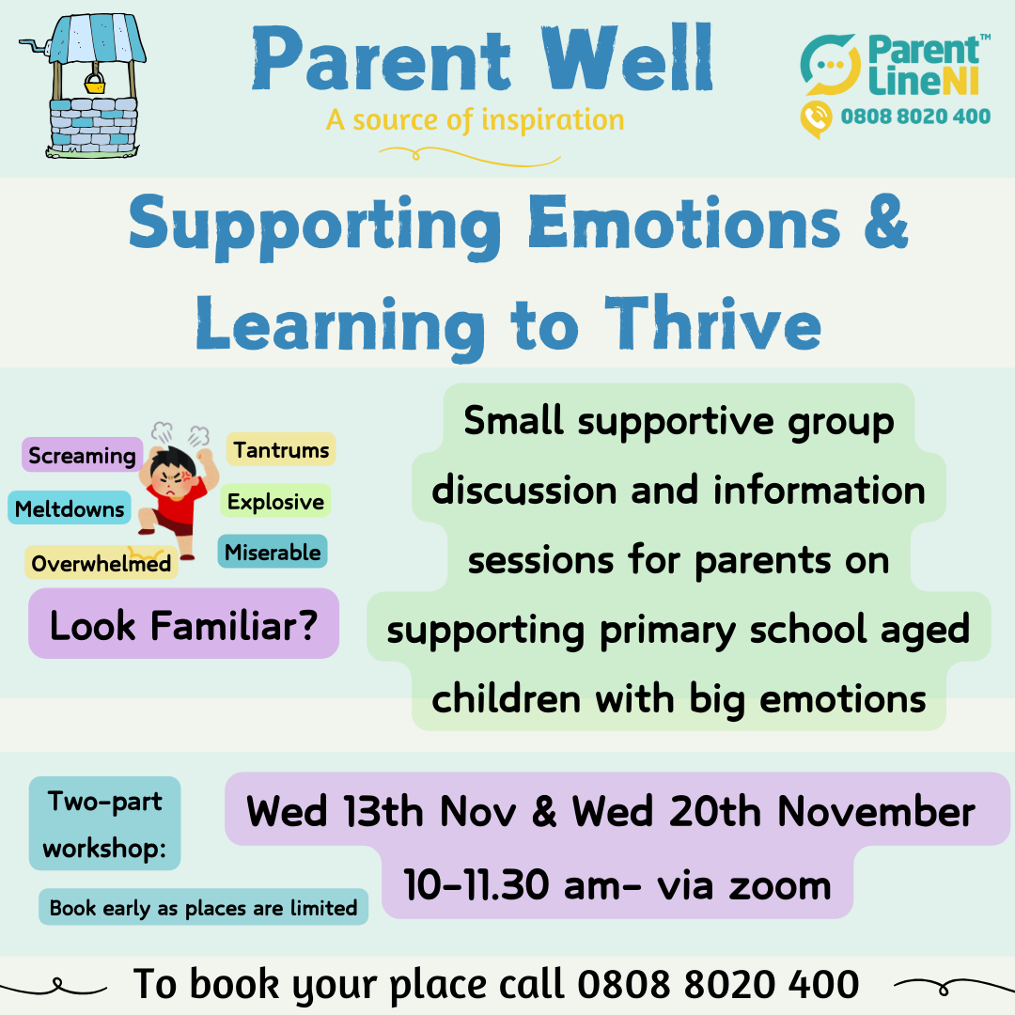

**Sacrament Dates 2024-25**

**Sacrament of Penance:** (Year 3)

Thursday 27 March 11.00am

**Sacrament of Confirmation:** (Year 7)

Friday 11 April 10.30am

**Sacrament of Communion:** (Year 4)

Saturday 17 May 10.30 am

**Do This In Memory Sundays**

Year 4 Holy Communion Class

November 24th 2024

December 15th 2024

**All at the 9.30am Mass**

**Registration P1 September 2025**

**If you have a child starting school in September or know someone who is, please contact the school to register your interest.**

Phone: 02827662664

Email:  [**info@stbrigidsps.ballymoney.ni.sch.uk**](mailto:info@stbrigidsps.ballymoney.ni.sch.uk)

Application process is online this year and opens on 10 January 2024 at 12noon (GMT) and closes on 24 January 2024 at 12noon