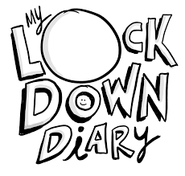

Life of a P5 during COVID 19

Living through the Coronavirus is boring because we have to stay indoors all day. We are allowed out for a walk everyday but when another person is walking towards you we have to cross the road to keep our distance. Keeping our distance from other people is important at the minute to stop the spread of the disease. I miss being able to visit my wee nephew Jax. He’s two at the minute and doesn't understand why I can’t go up so we video chat instead. The Prime Minister got the virus last week but is now at home. It’s weird not going to school everyday and I miss moaning about having to do work. I miss playing tag at break and lunch. I also can’t go horse riding at the minute 😭😭😭😭 or dance lessons or piano and swimming. People now wear masks and gloves. I tried a mask on and it really smelled. My mum is still working because she’s a cleaner and is now known as a key worker so I have to go to my aunt’s most days. Mum gets stopped with the police so they know she’s out for a reason. I can’t wait to play outside in my avenue with my friends and get a McDonalds. I really miss mum giving me money in the morning and letting me go into Tescos to get my lunch because kids aren’t allowed in shops at the minute. I really hope I can have a birthday party with all my friends in June with a bouncy castle and I can’t wait until my dog is allowed to kiss my hands again because the hand wash we have to use makes dogs sick. I’ve started getting a rash because we have to wash our hands ALL the time with hand sanitiser. I can’t wait until everything goes back to normal and the lockdowns lifted.

