The World Around Us
(Science, Technology, Geography and History.)
Our theme for this term is
What’s the forecast?
This study will include:
- seasonal changes in weather
- examining forecasts in various formats
- learning about how weather in other places differs from that in their own area
- mapwork to identify places mentioned in weather forecasts
- how weather affects how people live and work
- the effects of seasonal change on humans
- observing and recording the weather in our area

Included in themed work are creative activities, simple science investigations, literacy tasks and activities which use ICT.

Some More Class Information
Homework – Homework in Class B will generally consist of Reading, Spellings and Maths. Weekly homework will be given out on Mondays and is due back in on Fridays.

PE – In term 1, Class B will have swimming on Tuesdays and PE on Fridays.

Breaktime snacks – The children are being encouraged to be ‘Healthy Eaters’ and bring in a healthy snack to eat at breaktime. This could include fruit, cheese, yoghurt, crackers or a small sandwich, for example.
SeeSaw – This will be a very beneficial tool for us to maintain communication throughout the year, so please try to check for updates on a regular basis.

Cooking – We will be cooking in Class B this term, a balance of sweet and savoury recipes. This is a fun, social activity, as well as incorporating some key life skills for the children.

Class Agreement – The children worked together to create our class rules. This is included on the reverse of this page.

Library Visits – Class B will be visiting the library this term, to read and borrow books.

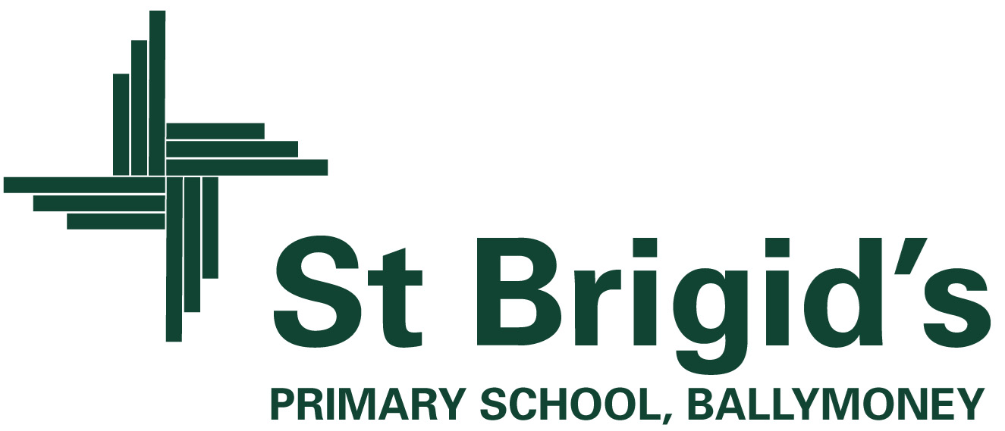
Curriculum Newsletter Class B Term 1

